Weather Application Help Document

Technologies

Back End: .NET 4.6, ASP.NET MVC5, ASP.NET Web API, REST sharp for REST client, Unity for Dependency Injection, Moq for mocking the data

Front End: HTML5, Bootstrap 3, Angular JS

Project Structure

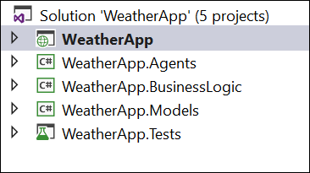

WeatherApp:

1. This is ASP.NET MVC5 proejct that holds the controllers and views.
2. Controllers folder has all the controllers.
3. Views folder has the single view Index.cshtml
4. Scripts folder has the javascripts including Angular JS controllers and services

WeatherApp.Agents:

1. This is .NET class library project that has helpers for REST client
2. This is responsible for handling REST API calls and has configurations for open weather map API.

WeatherApp.BusinessLogic:

1. This is .NET class library project that represent the Business Logic layer.
2. It has all the service definitions and implementations of business logic.
3. Also has sample data for Mocking the service.

WeatherApp.Models:

1. This is .NET class library project that represents Data Access Layer
2. It has all the model and DTO classes.

WeatherApp.Tests:

1. This is the unit test project for our application